
Architecture Specification
SCCore / Customer Contact Management

 | Name / Project Role | Signature | Date (dd/mmm/yyyy)
Author | Anass Ben Kirane / Architect Cognizant
 | Eric Chanson / Solution Architect (CGSC)
Approver* | Miguel Chaoui / IPL (IS Project Leader)
 | Mona
Distribution List
Names & Department | Rationale
Kaine Watkins, ITPL (ITS-IS)
Eduardo Pieber, Enterprise Architect (ITS-IS)
Version History
Version | Date (dd/mmm/yyyy) | Modification
0.1 | 24/08/2017 | Creation of the document
0.2 | 11/10/2017 | Split of FS and AS information

Table of Contents
1.1. Related Documents 4
1.2. Glossary 4
2.1. Production Environment 4
2.1.1. General Description 4
2.1.1.1. Reference Data 4
2.1.1.2. Master Data 5
2.1.1.3. Transactional Data 5
2.1.1.4. eMail and eFax behavior 7
2.1.1.5. Network Flow matrix: 8
2.1.1.5.1. User access 8
2.1.1.5.2. Data Integration 8
2.1.2. Servers Description 9
2.1.2.1. Software components details, example 9
2.1.2.2. Hardware details, example 9
2.1.3. Workstation Description 9
2.1.3.1. Hardware and Software specifications 9
2.1.3.2. Desktop recommended minimal configuration: 9
2.1.4. Printers Description 9
2.1.5. Data encryption within cloud 9
2.1.6. Security 9
2.2. Other Environments 10
2.2.1. Development Environment 10
2.2.2. Test Environment 10
2.2.3. Training Environment 11
2.2.4. Staging Environment 11
2.2.5. Disaster Recovery Environment 11

Introduction
The purpose of the Architecture Specification is to provide the description of the SCCore/CCM system detailed architecture, to identify the software and hardware components and to describe their implementation for the different environments (development, test, user acceptance, production).

Related Documents
Doc ID | Title

Glossary
Term or Acronym | Definition
SCCore | Supply Chain Core model
CCM | Customer Contact Management

Detailed Architecture Description

Production Environment

General Description
…

User access
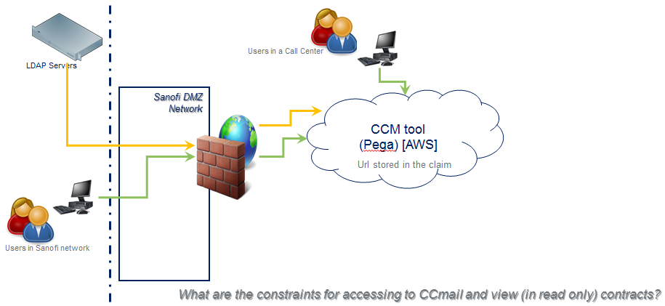

Reference and Master Data
Sources will be located inside the Sanofi network and Tibco will send them to CCM tool (PEGA). Sometimes we could use the Gateway (MFT) Sanofi platform for exchanging files between Source and CCM tool (PEGA).
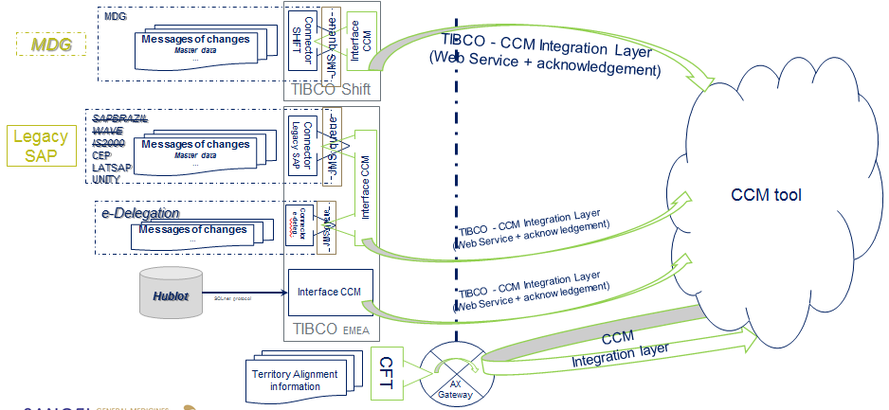

Transactional Data
Source will be CCM tool (PEGA) and it will use the Sanofi Layer7 platform for entering into the Sanofi network. 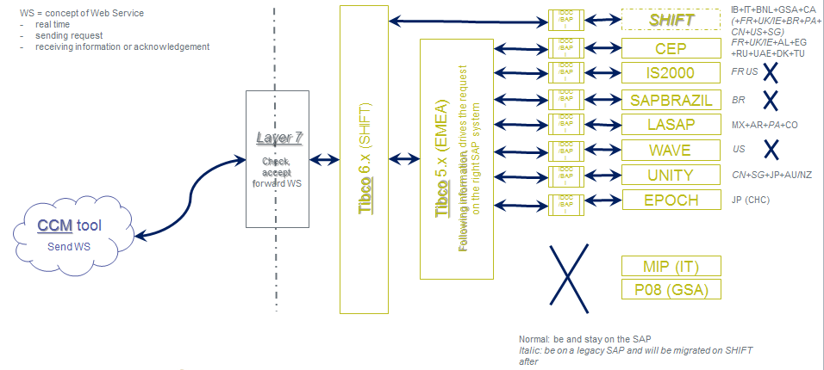

eMail and eFax behavior
The following implementation was done by Brazil with PEGA tool:
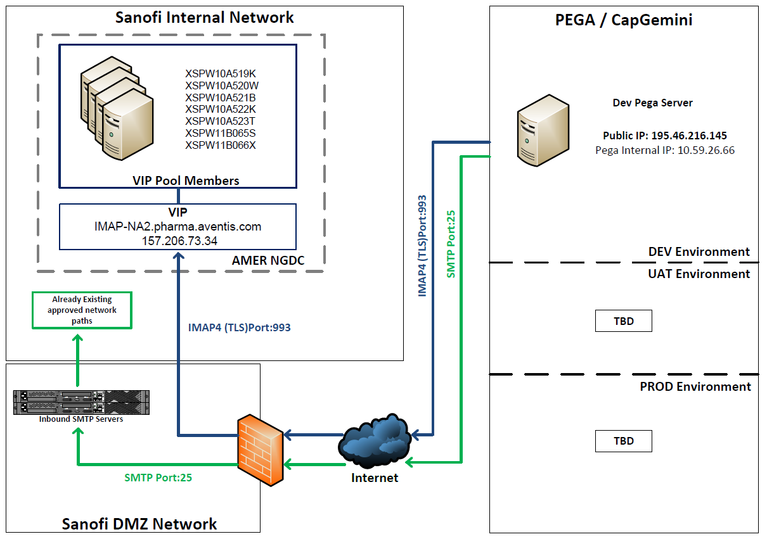
We would like something like this, but not in AMER NGDC but in EMEA NGDC:
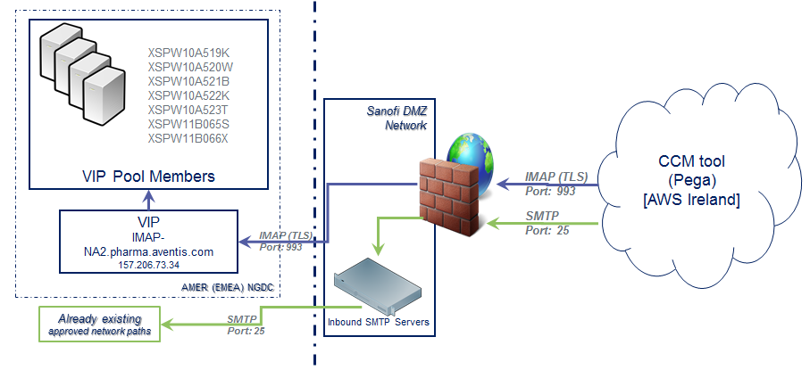

Network Flow matrix:

User access
Source | Destination | Service | Description
Access users – Internet | CCM Pega Cloud platform | HTTPS | End users are accessing the CCM pega platform from internet.
CCM Pega Cloud platform | SSO Identity provider | SAML 2.0 | Pega do not handle authentication of end user, Any incoming request to Pega CCM will be redirected to the Identification system that should authenticate the user and return back to Pega CCM with user details.

Data Integration
Source | Destination | Protocol | Description
E-Delegation | CCM Pega Cloud platform | REST | CCM is receiving the list of employees having a DOA Level, E-Delegation is sending the list of all employees, Tibco layer should be filtering this list to get only employees related to the Targeted Country.
Sanofi eMAIL Server? | CCM Pega Cloud platform | IMAP/POP3 | CCM is expecting to receive emails from customers. CCM is listening to an email account inbox, Emails are processed by CCM and then removed from InBox.
CCM Pega Cloud platform | Sanofi eMAIL Server? | Secure SMTP | CCM is using the Email SMTP server to send email to customers.
CCM Pega Cloud platform | eFax Server | SMTP | CCM is using eFax to send faxes to customers. The Faxes are to be send as PDF attachment to an email mail box. eFax will pull those emails and transform to real faxes.
eFax Server | CCM Pega Cloud platform | IMAP/POP3 | CCM is expecting to receive faxes from customers; the faxes are pushed as attachments to emails and placed in the Inbox of an agreed email account. CCM will pull the incoming emails and get the attachments.
Master Data  (Customers, Products, Territory Alignment, Contracts) | CCM Pega Cloud platform | REST | CCM platform is expecting to receive master data from Backend system. The initial load will be via csv files manually loaded in CCM. Then Only the Delta details are sent to the CCM via web services exposed by CCM.
CCM Pega Cloud platform | Layer 7 | REST | Layer 7 will be exposing services that are illustrated in the table above to perform transactions.
Layer7 | Tibco 6.x | HTTPS
Tibco->SAPs

Servers Description

Software components details, example
Software | Version | Installation Order | Responsible | Comments
PEGA | ? | 1 | PegaSystem | This SaaS is maintained by PegaSystem for Sanofi by AWS in Ireland.
Core Model | ? | 2 | Integrator
Roll-out | ? | 3 | Integrator | This component has to be updated per country and installed per country

Hardware details, example
Servers | Status | Reference | Processor(s) | Memory | OS | Application Layer
Application server |  | https://snfccm-prd?.pegacloud.io/prweb |  |  | Tomcat | Web server Layer
Log server |  | https://snfccm-prd?.pegacloud.io/kibana/ |  |  |  | Monitoring layer
Report server |  | https://snfccm-prd?.pegacloud.io:8443/prsysmgmt/ |  |  |  | Reporting layer
SMTP server |  | smtp-eu.sanofi.com xspw10a428x.pharma.aventis.com |  |  |  | eMail/eFax layer
IMAP server |  | imap-na2.pharma.aventis.com |  |  |  | eMail/eFax layer
eFax |  | GB-GFDccmxxxx@sanofi.com  +33157620xxx |  |  |  | Virtual fax

Workstation Description

Hardware and Software specifications
The Pega is a web application and will be available through a browser.
Browser recommendations?

Desktop recommended minimal configuration:
Non applicable

Printers Description
Non applicable

Data encryption within cloud
Pega Cloud uses data-at-rest encryption (DARE) in all Pega Cloud customer instances to help you secure your application data, as well as to help you comply with industry-standard security requirements. "Data at rest" refers to any content that is saved on a hard drive. Pega Cloud provides 256-bit AES encryption of data-at-rest.
Please check this link for additional details:
https://pdn.pega.com/data-rest-encryption-pega-cloud/data-rest-encryption-pega-cloud-0

Security
This section describes the security aspects related to services exposed by Pega. Those services are used for:
- Getting master data details from backend.
- Getting updates from backend regarding requests status (Unblock of credit for instance).
Each service defined in Pega is related to a service package. For CCM the service package that will cover all the services is “CCMServices”. This rule in Pega defines
https://pdn.pega.com/pega-cloud-security-standards/pega-cloud-security-standards

Other Environments

Development Environment
Servers | Status | Reference | Processor (s) | Memory | OS | Application Layer
Application server | OK | https://snfccm-dt1.pegacloud.io/prw |  |  |  | Web server layer
Log server | OK | https://snfccm-dt1.pegacloud.io/kibana/ |  |  |  | Monitoring layer
Report server | OK | https://snfccm-dt1.pegacloud.io:8443/prsysmgmt/ |  |  |  | Reporting layer
SMTP server |  | smtp-eu.sanofi.com xspw10a428x.pharma.aventis.com |  |  |  | eMail/eFax layer
IMAP server |  | imap-na2.pharma.aventis.com |  |  |  | eMail/eFax layer
eFax | OK | GB-GFDccmdev1@sanofi.com  +33157620389 |  |  |  | Virtual fax

Test Environment
Servers | Status | Reference | Processor (s) | Memory | OS | Application Layer
Application server | Ok | https://snfccm-dt2.pegacloud.io/prweb |  |  |  | Web server layer
Log server | Ok | https://snfccm-dt2.pegacloud.io/kibana/ |  |  |  | Monitoring layer
Report server | Ok | https://snfccm-dt2.pegacloud.io:8443/prsysmgmt/ |  |  |  | Reporting layer
SMTP server |  | smtp-eu.sanofi.com xspw10a428x.pharma.aventis.com |  |  |  | eMail/eFax layer
IMAP server |  | imap-na2.pharma.aventis.com |  |  |  | eMail/eFax layer
eFax | Ok | GB-GFDccmdev2@sanofi.com  +33157620390 |  |  |  | Virtual fax

Training Environment
Servers | Status | Reference | Processor (s) | Memory | OS | Application Layer
Application server |  | https://snfccm-stg1.pegacloud.io/prweb |  |  |  | Web server layer
Log server |  | https://snfccm- stg1.pegacloud.io/kibana/ |  |  |  | Monitoring layer
Report server |  | https://snfccm- stg1.pegacloud.io:8443/prsysmgmt/ |  |  |  | Reporting layer
SMTP server |  | smtp-eu.sanofi.com xspw10a428x.pharma.aventis.com |  |  |  | eMail/eFax layer
IMAP server |  | imap-na2.pharma.aventis.com |  |  |  | eMail/eFax layer
eFax |  | GB-GFDccmstg1@sanofi.com  +33157620xxx |  |  |  | Virtual fax

Staging/UAT Environment
Servers | Status | Reference | Processor (s) | Memory | OS | Application Layer
Application server |  | https://snfccm-stg2.pegacloud.io/prweb |  |  |  | Web server layer
Log server |  | https://snfccm- stg2.pegacloud.io/kibana/ |  |  |  | Monitoring layer
Report server |  | https://snfccm- stg2.pegacloud.io:8443/prsysmgmt/ |  |  |  | Reporting layer
SMTP server |  | smtp-eu.sanofi.com xspw10a428x.pharma.aventis.com |  |  |  | eMail/eFax layer
IMAP server |  | imap-na2.pharma.aventis.com |  |  |  | eMail/eFax layer
Fax |  | GB-GFDccmstg2@sanofi.com  +33157620xxx |  |  |  | Virtual fax

Disaster Recovery Environment
Hardware | Software | Description | Recovery Strategy | Replication / Backup Method | Prod Location/ Recovery Location
 |  | Web server, Monitoring, Reporting, database layers | The Pega Cloud Database Replication service protects production environments by deploying a real-time database mirror in a different availability zone. Failover to the production mirror is automatic, with a recovery point objective (RPO) of approximately 1 minute. Please check the link below.  https://pdn.pega.com/pega-cloud-data-backup-and-recovery/pega-cloud-data-backup-and-recovery | Using the AWS synchronization between Ireland and ? | AWS Ireland  /  AWS ?
 |  | eFax | The same as the DRP for exchange server (for the eMail part).  The DRP of Orange provider for the fax number.

* Signatures above indicate approvers agree with the content of the document and ensure it will be applicable within their domain of expertise.

